ABOUT US

Company information

Daily Sun Pharmaceutical Company limited is a limited liability Company that is engaged in the business of manufacturing and distribution of healthcare products with over 150 workers. We have our manufacturing site in the industrial layout of Ogun State Nigeria; about 40km from the nearest international airport; Muritala Mohammed airport Lagos producing a wide range of ethical and over the counter (OTC) formulations (Anti-malaria, multivitamins Analgesic, Antitussives and Antioxidants) for human healthcare.

Our History

Daily Sun Pharmaceutical Company limited formally known as Leady Pharma Industries Limited Company which started operations in the early 80s. It started it operation at No. 94, Ladip Street, Matori area Mushin Oshodi Lagos and was later moved to plot 3 & 4 Tomori industrial estate off Idiroko road Ota Ogun state due to space constraint. It was bought over by new investors Jessy pharmaceutical company limited; a subsidiary of Daily sun pharmaceutical company limited in August 2019 and commenced operation in 2021 after approval and due recognition by relevant agencies and bodies including the National Agency for Food and Drug Administration and Control (NAFDAC) and the Pharmacist Council of Nigeria (PCN). The company is engaging in the business of manufacturing and distribution of pharmaceutical products with the aim of becoming one of the leading players in the pharmaceutical landscape in Nigeria. We currently run a cGMP compliant manufacturing facility and certified by regulatory bodies in Nigeria (NAFDAC & PCN). The company has different dosage form manufacturing lines ranging from dry powders, capsules, tablets, creams and ointments. The company is headed by the Chairman who is acting on behalf of the Board of Trustees and being assisted by the Managing Director.

Daily Sun Pharmaceuticals Company Limited’s customer base is fast growing and our network is nationwide with distribution centers in Lagos, Kano, Onitsha, Aba, Imo & Ogun Sate Nigeria.

Mission Statement

We aim to deliver unique & qualitative healthcare products and services that will increase the life expectancy of Nigerians and bring good health to humanity in accordance with the ethics of professional care.

Vision Statement

Our vision is to meet the existing and future needs of the healthcare industry in Nigeria by partnering with other stakeholders; and also, be among the first (10) in the pharmaceutical/ healthcare industry; thereafter, through innovation and research, aspiring to become a global enterprise.

RESPONSIBILITY

Health, Safety and Environment policy

Daily Sun Pharmaceutical Company Limited is committed to achieving the highest Health, Safety and Environment standard throughout its business activities and monitor several HSE indicators in order to achieve continuous improvement of process capabilities and HSE performances. The Company shall regularly revise and improve the content of this policy.

We intend to fulfill this commitment based on the following objectives:

* Considering Health, Safety and Environment matters a priority in all Company activities, promoting company-wide Safety and Environment protection culture by reducing all HSE risk to a level as low as reasonably practicable.
* Considering the safeguard of the health and safety of its employees and those who may be affected by its operation as a fundamental requisite.
* Promoting the psycho-physical well-being of its workers through proactive identification of health and safety risk.

In order to achieve these objectives, Daily Sun Pharmaceutical Company assures:

* appropriate human and technical resources available.
* working proactively with Employees, Client, Sub-Contractors, And the Public and Governmental Agencies.
* Providing adequate knowledge and skills to all employees on HSE issues.

Company’s HSE policy

The Daily Sun Pharmaceutical Company Promises it’s WELLNESS FOR EVERYBODY, and to fulfill this promise we are totally committed to maintaining the highest Health, Safety and Environmental standards. This way, all our employees, customers, visitors, contractors and other stakeholders will benefit from our Policy to:

* Educate, train and motivate Daily Sun Pharmaceutical company team to work in a safe, environmentally responsible manner.
* Reduce impact of our products through their life-cycle.
* Manage HSE risk and performance effectively; actively seeking and acting upon meaningful opportunities to reduce risk and improve our HSE performance.
* Encourage effective communication of HSE manners with stakeholders, both internal and external.
* Make our work place free from recognized hazards and to reduce residual risks associated with our work to as low as reasonably practicable.
* Ensure compliance with HSE laws, regulate in all the countries we operate.
* Engage suppliers and business partners with ability to run safe and environmentally responsible operations.
* Ensure HSE in the workplace has ownership and commitment demonstrated through visible felt leadership across all level of management and business streams.
* Provide necessary incentives for all employees to promote safety culture.
* To regularly review the policy for alignment to our Shared Values and Key Stakeholders expectations.

Quality Policy

Our corporate quality policy is to make quality the responsibility of everybody within the organization, build quality into our products and services, and continuously improve the quality of our operations, with a view to meeting our customers’ expectations and satisfying their needs. We Comply with the guidelines of national and international regulatory organizations affecting our operations including the guidelines of NIS ISO 9001:2015 and best practices in manufacturing and services delivery.

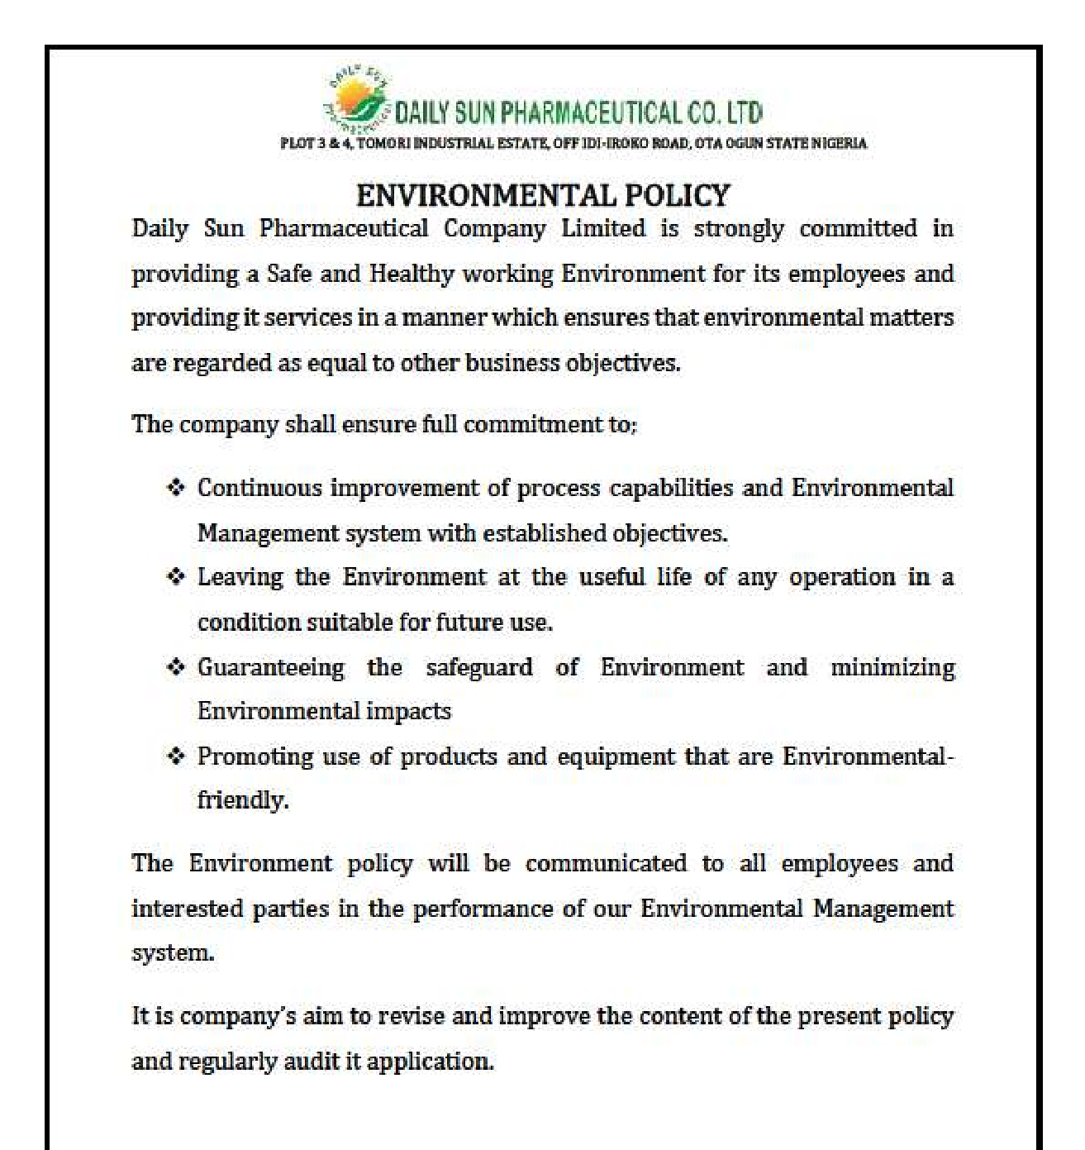

Board of Directors (Pictures)

Mr. John Chiadizue Chukwuemeka Chairman

Mr. Uche Kingsley Chukwuemeka Managing Director

Mr. Kennedy Aniebonam Operation Manager

Management Team (Pictures)

Pharm Emeka Ani Superintendent Pharmacist

Pharm Onyeka Okenu Production Manager

Mr. Lawson Ozebu Human Recourse Manager

Mr. Anele Samuel Chief Accountant

Mrs. Keleko Adefoyeke Adetutu Quality Manager

Engr. Mathew Acting Engineering Manager

CAREER

Are you interested in us? We’ll help you to open doors, provide you with the tools you need to thrive and encourage you to explore the world that sits outside your comfort zone. All of our colleagues are encouraged to discover and embrace new experiences, explore opportunities and learn from others. Because when you grow – we all grow.

Growth is about finding something that challenges you, that pushes you to change. If it doesn't scare you

a little bit, it's probably not enough of a growth opportunity.

OUR PRODUCTS (Pictures)

List of products

|  |  |  |  |
| --- | --- | --- | --- |
| s/n | Name | Active | claim |
| 1. | Jessy Hemoglobin Syrup | Heamoglobin Powder  Ferric Ammonium Citrate  Vitamin B12 | 250mg/5ml  18.76mg/5ml  20.00mcg/5ml |
| 2. | Jessy Hemoglobin Caplet | Hemoglobin  Vitamin B1  Vitamin B2  Vitamin B3  Vitamin B6  Vitamin B12  Vitamin A  Vitamin D3  Vitamin C  Vitamin E  PABA  Folic Acid  L-Selenomethionine  Siberia Ginseng  Choline bitartrate | 500mg  0.50mg 0.50mg 0.25mg  0.25mg  20.0mcg 50.0mcg  2.50mcg  50.00mg  2.50mg 2.50mg  0.50mg  15.0mcg  20.00mg  50.00mg |
| 3. | Leadamol 500mg Tablet | Paracetamol Bp | 500mg |
| 4. | Leadamol Syrup | Paracetamol Bp | 500mg /5ml |
| 5. | Vitaferon Iron Tonic | Ferric Ammonium citrate | 400mg/5ml |
| 6. | Vitaferon Blood Tonic Plus | Ferric Ammonium citrate | 200mg/5ml |
| Vitamin B1 | 2mg/5ml |
| Vitamin B2 | 1mg/5ml |
| Vitamin B3 | 6mg/5ml |
| Vitamin B6 | 2mg/5ml |
| Vitamin B12 | 5mcg/5ml |
| Folic Acid | 0.5mg/5ml |
| 7. | Jessy Orange Flavoured ORS | Dextrose Sodium Chloride  Sodium Citrate | 13.50g/ pouch  2.60g/ pouch  2.90g/ pouch |
|  |  | Potassium Chloride | 1.50g/ pouch |
| 8. | Jessy Non- Flavoured ORS | Dextrose Sodium Chloride  Sodium Citrate  Potassium Chloride | 13.50g/ pouch  2.60g/ pouch  2.90g/ pouch  1.50g/ pouch |
| 9. | Dr. Jessy Vitamin C 1000mg Tablet | Ascorbic Acid | 1000mg |
| 10. | Ferrous Sulphate Tablet | Ferrous sulpahte | 200mg |
| 11. | Diphenkof Syrup For Children | Sodium Citrate BP | 28.50mg/5ml |
| Diphenhydramine Hcl BP | 7.00mg/5ml |
| 12. | Diphenkof Expectorant For Adult | Ammonium Chloride BP  Sodium Citrate BP  Diphenhydramine HCL BP  Menthol Crystal BP | 130.00mg/5ml  57.00mg/5ml  12.50mg/5ml  1.10mg/5ml |
| 13. | Dr. Jessy Vitamin C Plus Zinc Caplet | Ascorbic Acid | 1000mg |
| Zinc Sulphate monohydrate | 50mg |
| 14. | Dr. Jessy Eye Clear With Lutein And Zeaxanthin | Ascorbic Acid  Vitamin A  Vitamin E  Vitamin B3  Vitamin B2  Heamoglobin  Zinc as Zinc Gluconate  Selenium as L-Selenomethionine  Manganese  Bilberry fruit Extract  Lutein  Zeaxanthin | 250.00mg  10,000IU  100IU  20mg  5mg  5mg  5mg  100mcg  20mcg  10mg  10mg  1.0mg |
| 15. | Skeno Balm | Methyl Salicylate  Eucalyptus Oil  Industrial Camphor  Menthol Crystal | 15.0%/jar  1.0%/jar  10.0%/jar  5.0%/jar |
| 16. | Dr. Jessy Zinc Caplet | Zinc Sulphate | 100mg |

Multivitamin

Jessy Hemoglobin Syrup

Jessy Hemoglobin caplet

Iron Supplement

Vitaferon Iron Tonic

Vitaferon Plus Blood Tonic

Ferrous Sulphate Tablet

Immune booster

Jessy Vitamin C 1000mg Caplet

Jessy Vitamin plus Zinc Caplet

Jessy Zinc 100mg Caplet

Eye clear with zeaxanthin and lutein Analgesic

Leadamol Tablet by 96

Leadamol Tablet by 1000

Leadamol Syrup

Antitussives

Diphenkof Expectorant for Adult

Diphenkof Syrup for Children

Electrolyte Oral pharmacological group.

Jessy Flavoured ORS Powder

Jessy Non-Flavoured ORS powder

Ointment

Skeno balm

NEWS AND ACTIVITIES

FACILITY TOUR

Daily sun pharmaceutical company being cGMP compliant facility has upgraded its production capacity and also ensuring high quality affordable products for the masses by acquiring many advanced capacity machines for production and analysis of raw materials and finished products

These include new HPLC Machines, rapid mixer machine, blenders, automatic filling and capping machines etc.

Facility pictures

CONTACT US

Get in touch

If you have any questions about our products, please use the form below. We will respond to all queries and comments within 24 hours.

Your name:

Your email:

Phone number:

Company name:

Subject:

Your message:

Send

Head Office: Plot 3 & 4 Tomori Industrial, estate off Idi Roko road Ota Ogun state Nigeria

Tel; 09160743899

Email: dailysunpharmacoltd@gmail.com

Facebook page @ Daily Sun Pharmaceutical Co. Ltd (https://web.facebook.com/me/)

Warehouse:

13B Acme road ogbaegbe industrial layout Ikeja Lagos

Email: Jessypharmacoltd@gmail.com